|  |  |
| --- | --- |
| **Ex. No: 1** | **Personal CV Using HTML** |
| **13.07.2023** |

**Aim:**

To create a CV using only HTML.

**Algorithm:**

1. Plan your CV.
2. Create a HTML document.
3. Add the required content.
4. Preview and Save

**Program:**

<!DOCTYPE html PUBLIC "-//W3C//DTD XHTML 1.0 Transitional//EN" "http://www.w3.org/TR/xhtml1/DTD/xhtml1-transitional.dtd">

<html xmlns="http://www.w3.org/1999/xhtml" xml:lang="en" lang="en">

<head>

<meta http-equiv="Content-Type" content="text/html; charset=utf-8"/>

<title>file_1689783909040</title>

<style type="text/css"> * {margin:0; padding:0; text-indent:0; }

h1 { color: #003579; font-family:Calibri, sans-serif; font-style: italic; font-weight: bold; text-decoration: none; font-size: 20.5pt; }

.p, p { color: black; font-family:Calibri, sans-serif; font-style: normal; font-weight: normal; text-decoration: none; font-size: 11pt; margin:0pt; }

.s1 { color: #003579; font-family:Calibri, sans-serif; font-style: italic; font-weight: normal; text-decoration: none; font-size: 11pt; }

.s2 { color: black; font-family:Calibri, sans-serif; font-style: italic; font-weight: normal; text-decoration: none; font-size: 11pt; }

.s3 { color: #003579; font-family:Calibri, sans-serif; font-style: italic; font-weight: bold; text-decoration: none; font-size: 11pt; }

.s4 { color: black; font-family:Calibri, sans-serif; font-style: italic; font-weight: bold; text-decoration: none; font-size: 11pt; }

h2 { color: black; font-family:Calibri, sans-serif; font-style: normal; font-weight: bold; text-decoration: none; font-size: 11pt; }

.s5 { color: black; font-family:Calibri, sans-serif; font-style: normal; font-weight: bold; text-decoration: none; font-size: 11pt; }

.s6 { color: black; font-family:Calibri, sans-serif; font-style: italic; font-weight: normal; text-decoration: none; font-size: 11pt; }

.s7 { color: black; font-family:Calibri, sans-serif; font-style: normal; font-weight: normal; text-decoration: none; font-size: 11pt; }

li {display: block; }

#l1 {padding-left: 0pt; }

#l1> li>*:first-child:before {content: "• "; color: black; font-family:Symbol, serif; font-style: normal; font-weight: normal; text-decoration: none; font-size: 11pt; }

table, tbody {vertical-align: top; overflow: visible; }

</style>

</head>

<body>

<h1 style="padding-left: 79pt;text-indent: 0pt;line-height: 25pt;text-align: center;">Amoghavarsh Hiremath</h1>

<p style="padding-top: 2pt;padding-left: 79pt;text-indent: 0pt;text-align: center;">Karnataka,India</p>

<p class="s1" style="padding-top: 2pt;padding-left: 79pt;text-indent: 0pt;text-align: center;">E-mail: <a href="mailto:austinjaisonj@gmail.com" style=" color: black; font-family:Calibri, sans-serif; font-style: italic; font-weight: normal; text-decoration: none; font-size: 11pt;" target="_blank">amoghash80</a><span class="p">@gmail.com </span>Phone number: <span class="p">+91 6360803602</span></p>

<p class="s3" style="padding-top: 7pt;padding-left: 11pt;text-indent: 0pt;text-align: left;"><a name="bookmark0">Education</a></p>

<p class="s4" style="padding-left: 5pt;text-indent: 23pt;line-height: 20pt;text-align: left;"><a name="bookmark1">B-Tech: Computer Science with Specialization in IoT </a><span class="s2">Shiv Nadar University Chennai Bachelor’s degree program (4th Semester ongoing) 2021-2025</span></p><p class="s2" style="padding-left: 27pt;text-indent: 0pt;line-height: 13pt;text-align: left;">GPA: 8.6</p><h2 style="padding-top: 6pt;padding-left: 27pt;text-indent: 0pt;text-align: left;">Class XII <i>Jambagi PU College</i></h2><p class="s2" style="padding-left: 27pt;text-indent: 0pt;line-height: 13pt;text-align: left;">Department of Pre-University Education(Karnataka) 2020-2021</p><p class="s2" style="padding-left: 27pt;text-indent: 0pt;line-height: 13pt;text-align: left;">Final Percentage: 97%</p><h2 style="padding-top: 6pt;padding-left: 27pt;text-indent: 0pt;text-align: left;">Class X <i>Phoenix Public School</i></h2>

<p class="s2" style="padding-left: 27pt;text-indent: 0pt;line-height: 13pt;text-align: left;">Indian Certificate of Secondary Education Examination (ICSE) 2018-2019</p><p class="s2" style="padding-left: 27pt;text-indent: 0pt;line-height: 13pt;text-align: left;">Final Percentage: 90.2%</p><p class="s3" style="padding-top: 6pt;padding-left: 11pt;text-indent: 0pt;text-align: left;"><a name="bookmark2">Portfolio of most relevant project</a></p><p style="text-indent: 0pt;text-align: left;"><br/></p>

<h2 style="padding-left: 24pt;text-indent: 0pt;line-height: 13pt;text-align: left;">StepWise <i>| Python, Streamlit, HTML-CSS,Arduino,ESP-32 Cam,OpenCV </i>|</h2>

<ul id="l1">

<li data-list-text="•">

<p style="padding-left: 62pt;text-indent: -18pt;text-align: left;">A footfall management application for analyzing the footfall data by performance metrics in a store given from the ESP-32 Camera module with Arduino by Human Detection using OpenCV.</p>

</li>

<li data-list-text="•">

<p style="padding-left: 62pt;text-indent: -18pt;text-align: left;">Aids the shopkeepers in knowing potential and performance of aisles to make marketing and advertising decisions on their products.</p>

<h2 style="padding-left: 27pt;text-indent: 0pt;line-height: 13pt;text-align: left;">SocioPath | <i>HTML-CSS,JavaScript,ReactJS |</i></h2>

</li>

<li data-list-text="•">

<p style="padding-left: 62pt;text-indent: -18pt;text-align: left;">An application which helps startups find guidance, funding and support, connecting people from all the different fields to professionals alike.</p>

</li>

<li data-list-text="•">

<p style="padding-left: 62pt;text-indent: -18pt;line-height: 13pt;text-align: left;">Provides an environment which supports innovations and solutions to grow.</p><h2 style="padding-left: 27pt;text-indent: 0pt;line-height: 13pt;text-align: left;">Traffic Alert System | <i>Arduino,HC-SR04,Buzzer |</i></h2></li><li data-list-text="•"><p style="padding-left: 62pt;text-indent: -18pt;text-align: left;">A prototype that uses Arduino and the HC-SR04 UV module to alert inattentive drivers on road that are approaching a stop light.</p></li><li data-list-text="•"><p style="padding-left: 62pt;text-indent: -18pt;line-height: 14pt;text-align: left;">Prevents accidents and keeps people from braking the rules.</p></li></ul><p class="s3" style="padding-left: 11pt;text-indent: 0pt;line-height: 13pt;text-align: left;"><a name="bookmark3">Skills</a></p><p style="text-indent: 0pt;text-align: left;"><br/></p><h2 style="padding-left: 27pt;text-indent: 0pt;text-align: left;">Technical/Tools</h2><p style="padding-left: 27pt;text-indent: 0pt;text-align: left;">C, C++,Python,SQL, Java, JavaScript, HTML, CSS, Tailwind CSS, Tableau,Data Science and Analytics, Data Structures and Algorithms,Competitive Programming, Arduino, Raspberry Pi</p><h2 style="padding-left: 27pt;text-indent: 0pt;line-height: 13pt;text-align: left;">General/Tools</h2><p style="padding-left: 27pt;text-indent: 0pt;line-height: 13pt;text-align: left;">Problem Solving, Communication, Flexibility</p><p style="text-indent: 0pt;text-align: left;"><br/></p>

<p class="s3" style="padding-left: 11pt;text-indent: 0pt;text-align: left;"><a name="bookmark4">Achievements and Certifications</a></p><p style="text-indent: 0pt;text-align: left;"><br/></p>

<p style="text-indent: 0pt;text-align: left;"><br/></p>

<table style="border-collapse:collapse;margin-left:24.844pt" cellspacing="0"><tr style="height:15pt"><td style="width:186pt"><p class="s5" style="padding-left: 2pt;text-indent: 0pt;line-height: 11pt;text-align: left;">Introduction to Soft Computing</p></td><td style="width:119pt"><p class="s6" style="padding-left: 15pt;text-indent: 0pt;line-height: 11pt;text-align: left;">April 2023</p></td><td style="width:179pt"><p class="s7" style="padding-right: 3pt;text-indent: 0pt;line-height: 11pt;text-align: right;">NPTEL</p></td></tr><tr style="height:19pt"><td style="width:186pt"><p class="s5" style="padding-top: 1pt;padding-left: 2pt;text-indent: 0pt;text-align: left;">Data Science for Engineers</p></td><td style="width:119pt"><p class="s6" style="padding-top: 1pt;padding-left: 14pt;text-indent: 0pt;text-align: left;">April 2023</p></td><td style="width:179pt"><p class="s7" style="padding-top: 1pt;padding-right: 3pt;text-indent: 0pt;text-align: right;">NPTEL</p></td></tr><tr style="height:21pt"><td style="width:186pt"><p class="s5" style="padding-top: 2pt;padding-left: 2pt;text-indent: 0pt;text-align: left;">SOI MUMPS Microfabrication Process</p></td><td style="width:119pt"><p class="s6" style="padding-top: 2pt;padding-left: 13pt;text-indent: 0pt;text-align: left;">March 2023</p></td><td style="width:179pt"><p class="s7" style="padding-top: 2pt;padding-right: 2pt;text-indent: 0pt;text-align: right;">Shiv Nadar University Chennai</p>

</td>

</tr>

<tr style="height:16pt"><td style="width:186pt"><p class="s5" style="padding-top: 2pt;padding-left: 2pt;text-indent: 0pt;line-height: 12pt;text-align: left;">Codeforces</p></td><td style="width:119pt"><p class="s7" style="padding-top: 2pt;padding-left: 11pt;text-indent: 0pt;line-height: 12pt;text-align: left;">Max Rated 848</p></td><td style="width:179pt"><p class="s7" style="padding-top: 2pt;padding-right: 3pt;text-indent: 0pt;line-height: 12pt;text-align: right;">Handle-ashtrichh</p></td></tr></table></body></html>

**Output:**

Github Link: https://github.com/AsHtrich/Web_tech2023

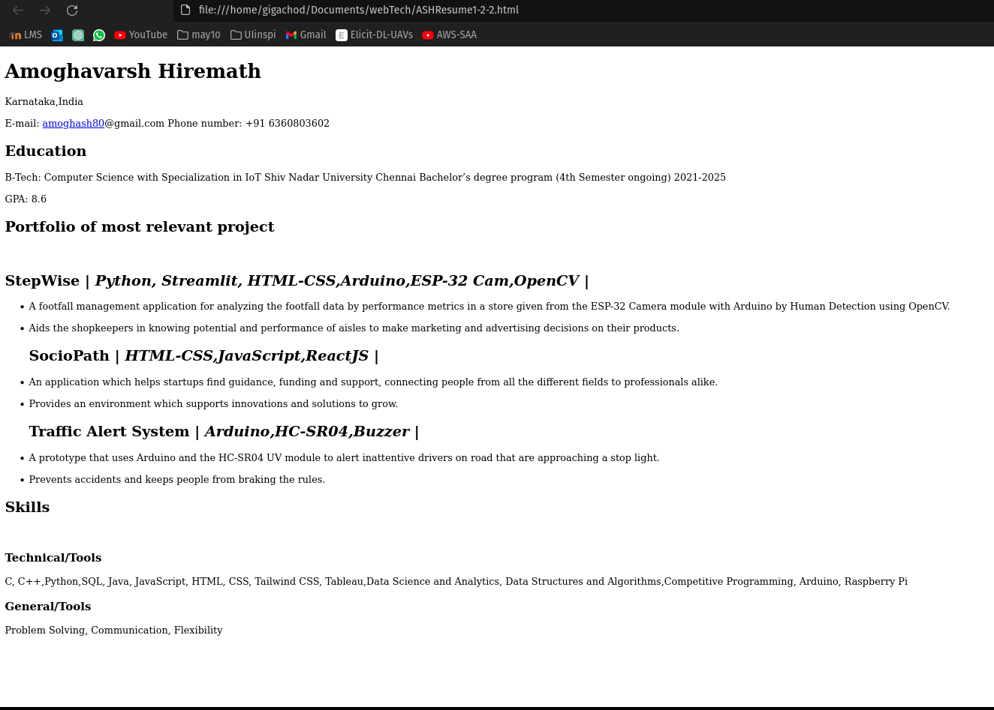

**Result:**

Therefore, we've successfully created a CV using HTML.